CLIMATE

Why James Hansen Is Wrong About Nuclear Power
BY JOE ROMM JAN 7, 2016 8:00 AM
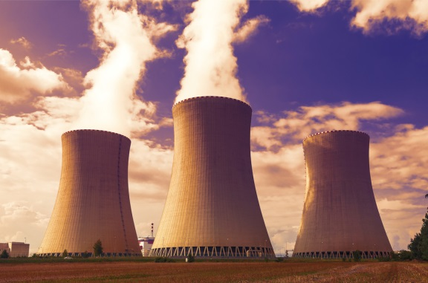

Climatologist James Hansen argued last month, “Nuclear power paves the only viable path forward on climate change.” He is wrong.
As the Nuclear Energy Agency (NEA) and International Energy Agency (IEA) explained in a major report last year, in the best-case scenario, nuclear power can play a modest, but important, role in avoiding catastrophic global warming if it can solve its various nagging problems — particularly high construction cost — without sacrificing safety.
Hansen and a handful of other climate scientists I also greatly respect — Ken Caldeira, Tom Wigley, and Kerry Emanuel — present a mostly handwaving argument in which new nuclear power achieves and sustains an unprecedented growth rate for decades. The one quantitative “illustrative scenario” they propose — “a total requirement of 115 reactors per year to 2050 to entirely decarbonise the global electricity system” — is far beyond what the world ever sustained during the nuclear heyday of the 1970s, and far beyond what the overwhelming majority of energy experts, including those sympathetic to the industry, think is plausible.
They ignore the core issues: The nuclear power industry has essentially priced itself out of the market for new power plants because of its 1) negative learning curve and 2) inability to avoid massive delays and cost overruns in market economies. This is doubly problematic because the competition — renewable power, electricity storage, and energy efficiency — have seen steady, stunning price drops for a long time.
Hansen et al also continue the myth that somehow nuclear power is being held back by environmental opposition, rather than its own marketplace failures, a point I will return to later.
Those interested in what new nuclear power can and cannot plausibly contribute to stopping global warming should start with the most objective, independent, and comprehensive analysis done in recent years — the 2015 “Technology Roadmap” from the IEA and NEA. Those agencies’ bottom is line is that, if the industry gets its act together — a big IF, given recent history — new nuclear power can play an important but limited role. This just happens to be what I’ve been arguing consistently on Climate Progress for a long, long time.
The IEA is the international body responsible for energy analysis, and one of the few independent agencies in the world with a sophisticated enough energy and economic model to credibly examine in detail the role of various low carbon technologies in a 2°C scenario (2DS) aimed at averting catastrophic climate change. The NEA was established by the OECD countries “To assist its member countries in maintaining and further developing, through international co-operation, the scientific, technological and legal bases required for a safe, environmentally friendly and economical use of nuclear energy for peaceful purposes.”
Here is what the IEA and NEA project is a plausible though “challenging” pathway for the nuclear energy industry in a 2DS world — if it can solve its cost and logistics problems:
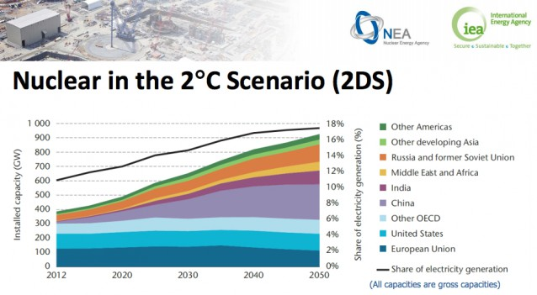
The IEA and NEA project nuclear could rise from its current 11 percent of world electricity capacity to 17 percent in 2050 in a carbon constrained world.
The core problem is that the price of new nuclear reactors has been rising for decades, and they are now extremely expensive, costing up to $10 billion apiece. Nuclear power appears to have a negative learning curve:
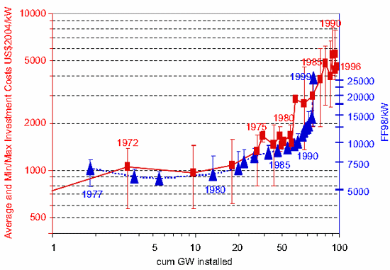
Average and min/max reactor construction costs per year of completion date for US and France versus cumulative capacity completed.
In the past several years, utilities have told state regulators that the cost of new nuclear plants is in the $5,500 to $8,100 per kilowatt range (see here and here).
A key reason new reactors are inherently so expensive is that they must be designed to survive almost any imaginable risk, including major disasters and human error. Even the most unlikely threats must be planned for and eliminated when the possible result of a disaster is the poisoning of thousands of people, the long-term contamination of large areas of land, and $100 billion in damages.
No wonder very few new plants have been ordered and built in the past two decades in countries with market economies, such as the United States. And that was before the 2011 Fukushima nuclear disaster. “Japan’s embattled utility Tokyo Electric Power Co now expects the compensation costs after the Fukushima nuclear disaster to be more than $57 billion,” Agence France-Pressewrote last year. That doesn’t even include the cost of decommissioning the reactors or “cleaning up the mess from the disaster.”
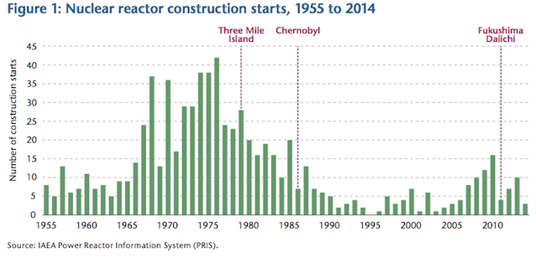
In 2014 there were only three new plants put under construction — and just 5 gigawatts of capacity were added.
In their “Nuclear Roadmap,” the IEA and NEA explain what level of capacity additions would be required in the 2 degrees Celsius scenario: “In order for nuclear to reach its deployment targets under the 2D scenario, annual connection rates should increase from 5 GW in 2014 to well over 20 GW during the coming decade.” That means returning to a nuclear build rate previously achieved for only one decade — 20 gigawatts per year during the 1980s. That target has many challenges in a post-Fukushima world.
The IEA and NEA themselves note that “such rapid growth will only be possible” if several actions take place including vendors demonstrating “the ability to build on time and to budget, and to reduce the costs of new designs.” Also, both governments and the industry need to maintain and improve safety. If such advances do occur, then new nuclear plants could provide a moderate amount of the needed new carbon-free power for the 2°C scenario.
But, to repeat, in the only quantitative scenario Hansen and colleagues offer, the world builds “115 reactors per year to 2050 to entirely decarbonise the global electricity system.” Rather than seriously discussing any of the multiple marketplace barriers to such an unprecedented sustained explosion in plant construction, they simply assert, “We know that this is technically achievable because France and Sweden were able to ramp up nuclear power to high levels in just 15-20 years.”
Seriously. Apparently they don’t think it relevant to let you know that Sweden has precisely … wait for it … 10 operational nuclear reactors! Yes, the fact that Sweden connected 10 reactors to the grid over a period of 15 years is somehow evidence the world could build “115 reactors per year to 2050.”
And what about the nation best known for its reliance on nuclear power? According to the online database of the International Atomic Energy Agency, France has 58 operational reactors, which took the country more than two decades to connect to the grid! That would be a rate of under three per year.
How do France or Sweden provide any evidence that 115 reactors per year for 35 years is “technically achievable”? Answer: They don’t.
So why do such smart people advance such an indefensibly absurd scenario? Because when you drop the numbers to more plausible (but still highly optimistic) levels, such as imagined by the IEA and NEA, you immediately realize that nuclear power isn’t going to be the major player in the fight to avoid catastrophic warming.
Indeed if we actually moved into the realm of sober realism, it becomes clear that new nuclear power is most likely to be a bit player. While Hansen et al tout France as a big success story, you’d never know from reading their article that, as the IEA and NEA note, “France, which today generates 75% of all its electricity from nuclear, still plans to reduce this share to 50% by 2025 while proposing to maintain nuclear capacity at its present level.”
In October, the Financial Times, not exactly a liberal enviro publication, detailed the “Tale of woe in French nuclear sector” marked by “multibillion-euro delays and a key national champion rescued from the brink of failure.”
Here is what happened when the two major French nuclear suppliers attempted to build “third-generation reactor technology, called the European Pressurised Reactor (EPR)” in market economies:
In Finland, the Areva-built Olkiluoto 3 reactor, the first EPR to be commissioned, is 10 years behind schedule and €5bn [$5.4 billion] over budget. It is expected to start up in 2018.
In September EDF announced delays for the EPR reactor in Flamanville, Normandy: initially expected to cost €3bn and start operations in 2012, it will not start until 2018 at a cost of €10.5bn [$11.3 billion].
The French couldn’t even build an affordable, on-schedule next generation nuke in their own nuclear-friendly country!
To be clear, I don’t think we should take nuclear power off the table or even prematurely shut down safe, working reactors. But it is time for rosy-eyed nuclear enthusiasts like Hansen to stop implying that somehow U.S. activists or progressive politicians are thwarting the Renaissance of an otherwise affordable and easy-to-scale major climate solution.
Nuclear power remains a highly subsidized energy source that benefits from a myriad of favorable policies in this country, including taxpayer-backed disaster insurance and loan guarantees.
Should we keep working on next-generation technology? Of course. The Department of Energy and others have been working to develop small modular reactors that could start to ramp up production in 2030 and beyond. Constructed in factories, these reactors would cost $3-5 billion each. Ideally, they would be much safer than the large reactors. Yet because they are smaller and generate much less electricity, it’s not clear that their cost per kilowatt hour of delivering electricity would be much lower than current nuclear plants.
Sober climate hawks need to remember the reality that the price of nuclear power has been headed up for decades. Equally problemmatic for nukes, the price of the zero-carbon competition to nuclear power has been headed down for decades, a trend that continues even now as explained in a November DOE report, “Revolution…Now The Future Arrives for Five Clean Energy Technologies.”
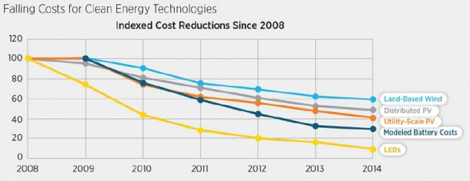
The good news is that, even in the worst-case scenario, where nukes continue to price themselves out of the low-carbon market, renewables could, in theory, do the job by themselves, as Stanford’s Mark Jacobson explains.
Bottom Line: If the world is able to put itself on the 2°C path in the coming years, and if the nuclear industry can resolve a variety of issues and avoid a major disaster, then nuclear power can make a modest but important contribution. At the same time, the IEA and many others have concluded that new renewable energy will play a far bigger role in the transition.
TAGS
- Climate Change
- Nuclear Power

